PROJECT REPORT
Automatic Grass Cutting Robot
An Embedded System Design with Obstacle and Rain Detection

Submitted by
Mukesh balan
23BEC0071

GIT LINK: https://github.com/mukeshbalanm2023-spec/23bec0071Automatic-Grass-Cutting-Robot.git

Table of Contents
Table of Contents 2
1. Problem Statement 3
Introduction 3
Objectives 3
2. Scope of the Solution 3
Scope 3
Future Scope 4
3. Block Diagram 4
4. Circuit Diagram 4
5. Required Components 4
Software 4
Hardware 5
6. Simulated Circuit 5
7. Code for the Solution 5
8. Results of Simulation 6
Normal Operation 6
Obstacle Detected 6
Rain Detected 6
9. Layout of the System 6
10. Gerber File 6
Included Files 6
11. Video of the Demo 7
12. References 7

1. Problem Statement

Introduction
Grass cutting is an essential maintenance activity in homes, parks, schools, industries, and commercial gardens. Conventional grass cutting methods require continuous human effort, consume considerable time, and may expose users to potential hazards from rotating cutting blades. Manual grass cutters also become inconvenient for elderly or physically challenged individuals.
To overcome these limitations, an Automatic Grass Cutting Robot is proposed. The robot is capable of moving autonomously while operating a grass-cutting mechanism. It continuously monitors its surroundings using an ultrasonic sensor to detect obstacles and stops automatically to avoid collisions. A rain detection mechanism is also incorporated to stop operation during rainy conditions, protecting the electronic components and ensuring safe operation.
The system is implemented using an Arduino Uno microcontroller and simulated in TinkerCad. A PCB is designed using KiCad to demonstrate the hardware implementation.

Objectives
- Develop an autonomous grass cutting robot.
- Reduce manual effort in lawn maintenance.
- Detect obstacles and stop automatically.
- Detect rain and suspend operation.
- Design and simulate the complete embedded system.
- Design a PCB and generate Gerber files.

2. Scope of the Solution
The Automatic Grass Cutting Robot is designed for small lawns, gardens, parks, and institutional campuses. It automatically performs grass cutting with minimal human intervention.

Scope
- Automatic movement.
- Grass cutting mechanism.
- Obstacle detection.
- Rain detection.
- Arduino-based control.
- PCB implementation.
- Simulation before hardware development.

Future Scope
- GPS navigation.
- Bluetooth control.
- Wi-Fi monitoring.
- Solar charging.
- Camera-based navigation.
- AI-based path planning.
- Automatic charging station.
- Mobile application.

3. Block Diagram
The block diagram below illustrates the overall architecture of the system, showing the flow of power and control signals between the battery, microcontroller, sensors, and actuators.
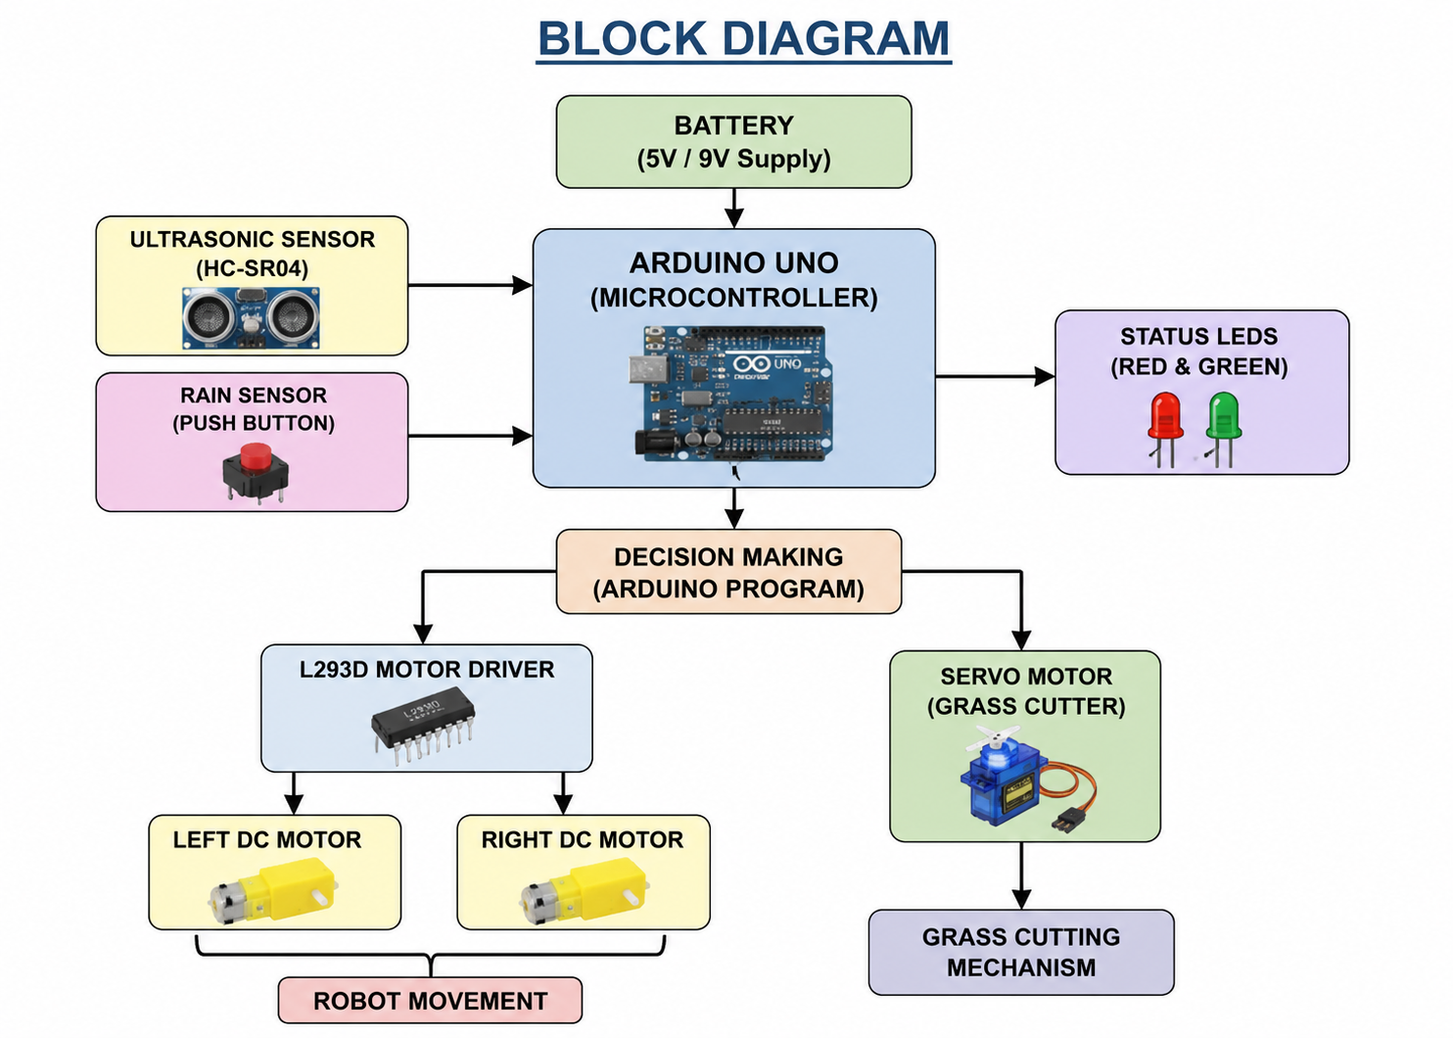

4. Circuit Diagram
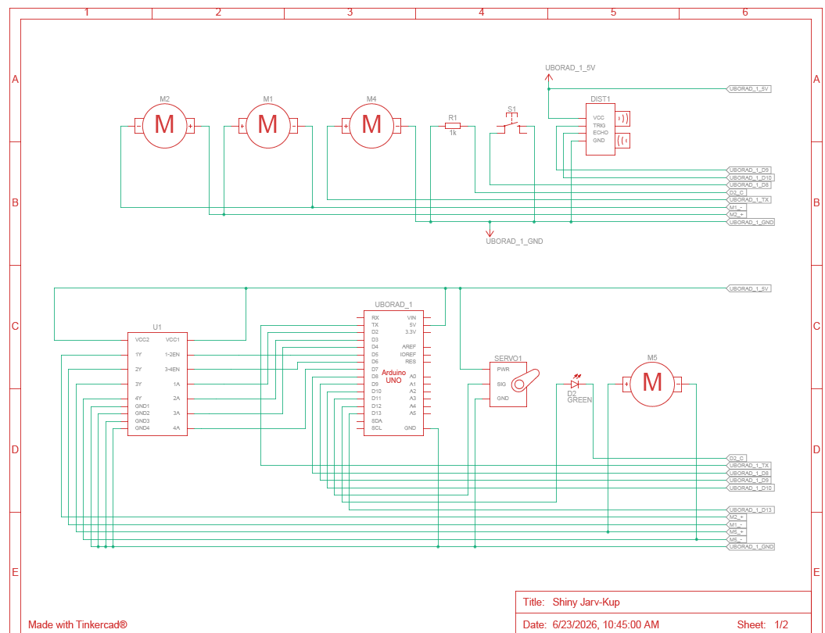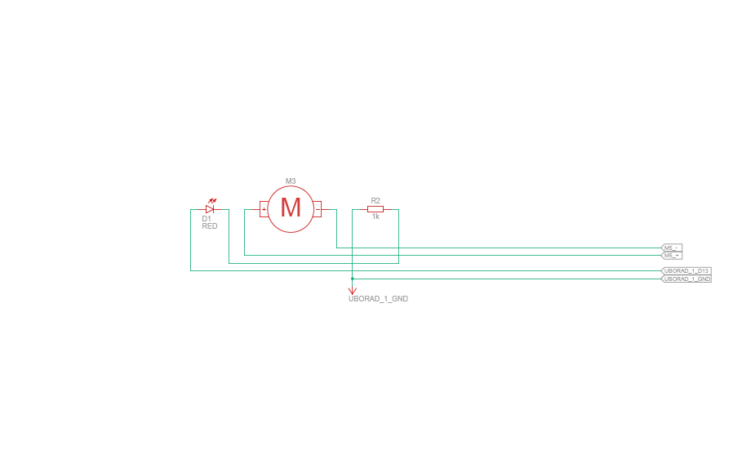

The circuit consists of an Arduino Uno, L293D motor driver, HC-SR04 ultrasonic sensor, servo motor, rain sensor (push button in simulation), LEDs, and DC motors. The Arduino processes sensor inputs and controls the movement and grass-cutting mechanism.

5. Required Components

Software
Software | Purpose
Arduino IDE | Programming
TinkerCad | Circuit Simulation
KiCad | PCB Design
GitHub | Project Documentation

Hardware
Component | Quantity
Arduino Uno | 1
L293D Motor Driver | 1
DC Motors | 2
Servo Motor | 1
HC-SR04 Ultrasonic Sensor | 1
Push Button (Rain Sensor Simulation) | 1
LEDs | 2
Resistors | 2
Battery | 1
Chassis | 1

6. Simulated Circuit
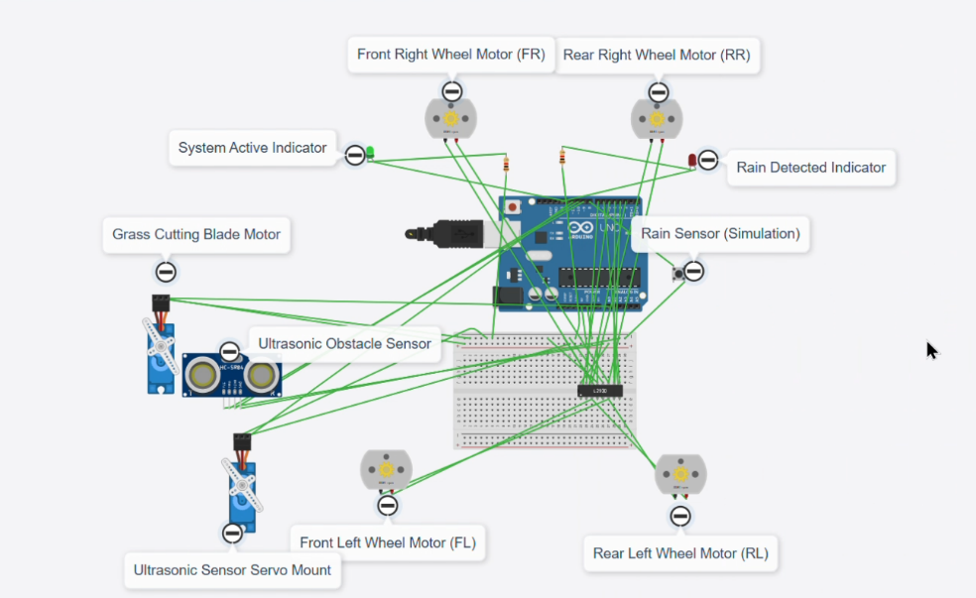

The complete circuit was simulated using TinkerCad. All components were tested under different operating conditions, including obstacle detection and rain detection.

7. Code for the Solution
Grass_Cutting_Robot.ino
#include <Servo.h>

Servo cutter;

// Motor Driver Pins
#define ENA 5
#define IN1 2
#define IN2 3
#define ENB 6
#define IN3 4
#define IN4 7

// Ultrasonic Sensor
#define TRIG 9
#define ECHO 10

// Servo
#define SERVO A0

// Rain Button
#define RAIN 8

// LEDs
#define GREEN 12
#define RED 13

int angle = 0;
int dir = 1;

void setup() {

pinMode(ENA,OUTPUT);
pinMode(ENB,OUTPUT);

pinMode(IN1,OUTPUT);
pinMode(IN2,OUTPUT);
pinMode(IN3,OUTPUT);
pinMode(IN4,OUTPUT);

pinMode(TRIG,OUTPUT);
pinMode(ECHO,INPUT);

pinMode(RAIN,INPUT_PULLUP);

pinMode(GREEN,OUTPUT);
pinMode(RED,OUTPUT);

cutter.attach(SERVO);

digitalWrite(GREEN,HIGH);
digitalWrite(RED,LOW);
}

long distance(){

digitalWrite(TRIG,LOW);
delayMicroseconds(2);

digitalWrite(TRIG,HIGH);
delayMicroseconds(10);
digitalWrite(TRIG,LOW);

long t=pulseIn(ECHO,HIGH);

return t*0.034/2;
}

void forward(){

digitalWrite(IN1,HIGH);
digitalWrite(IN2,LOW);

digitalWrite(IN3,HIGH);
digitalWrite(IN4,LOW);

analogWrite(ENA,255);
analogWrite(ENB,255);
}

void stopMotor(){

analogWrite(ENA,0);
analogWrite(ENB,0);

digitalWrite(IN1,LOW);
digitalWrite(IN2,LOW);
digitalWrite(IN3,LOW);
digitalWrite(IN4,LOW);
}

void cutterMove(){

cutter.write(angle);

angle += dir;

if(angle>=180 || angle<=0)
dir=-dir;

delay(8);
}

void loop(){

long d=distance();
bool rain=!digitalRead(RAIN);

if(rain){

stopMotor();

digitalWrite(GREEN,LOW);
digitalWrite(RED,HIGH);

cutter.write(90);

return;
}

if(d<20){

stopMotor();

digitalWrite(GREEN,LOW);
digitalWrite(RED,HIGH);

cutterMove();

}

else{

forward();

digitalWrite(GREEN,HIGH);
digitalWrite(RED,LOW);

cutterMove();

}

}

The Arduino program controls the movement of the robot, obstacle detection, rain detection, LEDs, and the grass-cutting servo.

8. Results of Simulation

Normal Operation
- Robot moves forward.
- Servo rotates continuously.
- Green LED glows.

Obstacle Detected
- Robot stops.
- Red LED glows.
- Grass-cutting servo continues moving.

Rain Detected
- Robot stops.
- Grass cutter stops.
- Red LED glows.
The simulation confirmed correct operation under all test cases.

9. Layout of the System
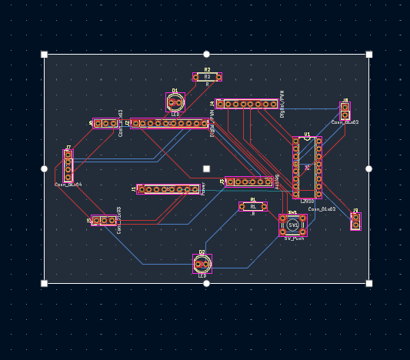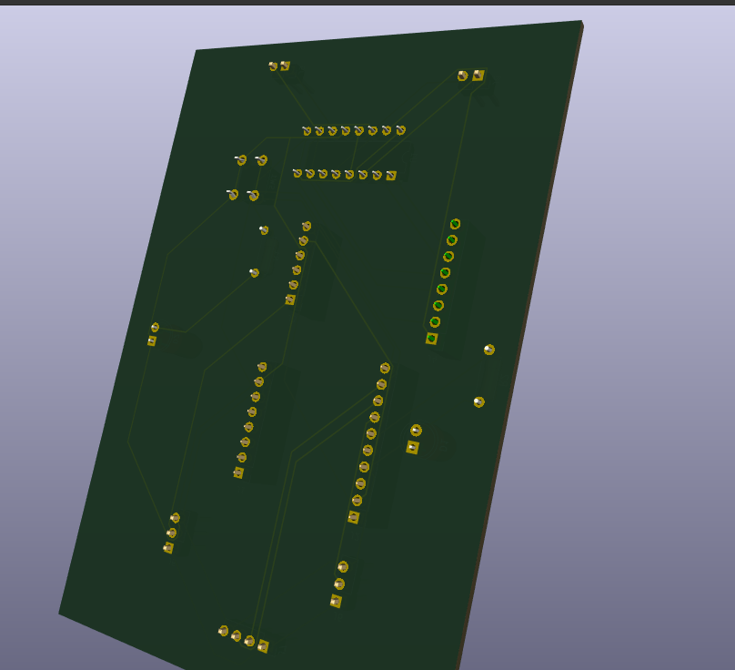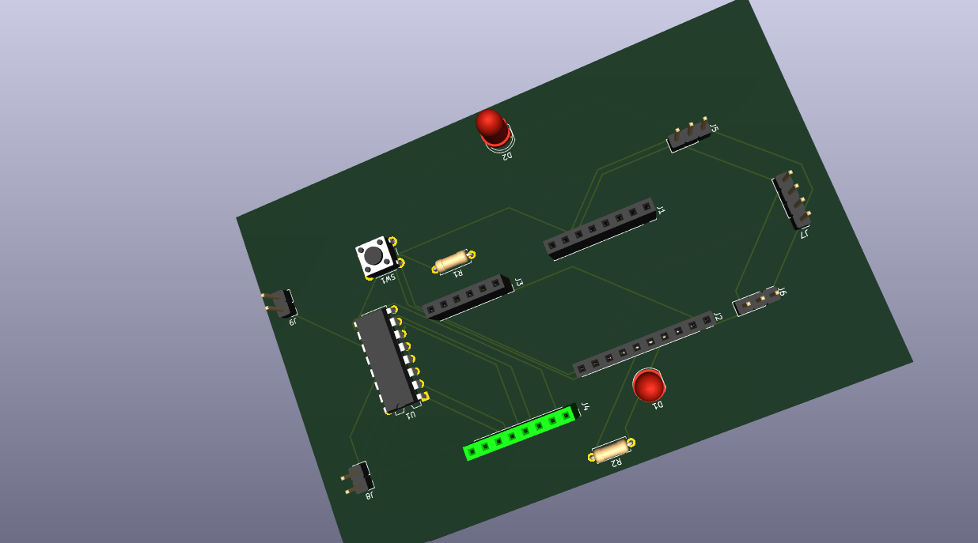

A two-layer PCB was designed in KiCad. The PCB includes footprints for the Arduino Uno shield, L293D motor driver, connectors, LEDs, servo motor, ultrasonic sensor, and rain sensor interface.

10. Gerber File
Gerber files were generated from the KiCad PCB design. These files are compatible with PCB manufacturing services and include all necessary copper, silkscreen, solder mask, edge cuts, and drill information.

Included Files
- F_Cu.gbr
- B_Cu.gbr
- F_Mask.gbr
- B_Mask.gbr
- F_Silkscreen.gbr
- B_Silkscreen.gbr
- Edge_Cuts.gbr
- Drill File
- Gerber Job File

11. Video of the Demo
A demonstration video link should be added below, hosted on Google Drive, GitHub, or YouTube (Unlisted).
GIT LINK: https://github.com/mukeshbalanm2023-spec/23bec0071Automatic-Grass-Cutting-Robot.git

The video should show:
- Circuit Simulation
- Robot Movement
- Obstacle Detection
- Rain Detection
- PCB Design

12. References
1. Arduino Documentation. https://www.arduino.cc
2. TinkerCad Circuits. https://www.tinkercad.com
3. KiCad Documentation. https://www.kicad.org
4. HC-SR04 Ultrasonic Sensor Datasheet.
5. L293D Motor Driver Datasheet.
6. Servo Motor Datasheet.
7. GitHub Documentation. https://docs.github.com

